PARTNERING WITH LOCAL GOVERNMENT

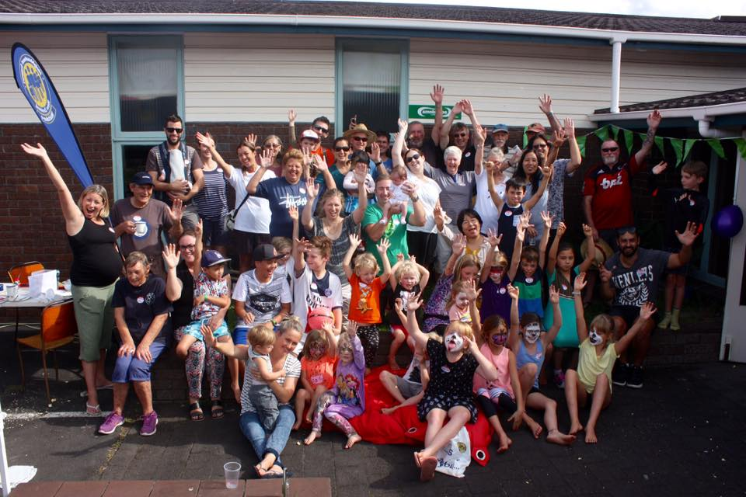

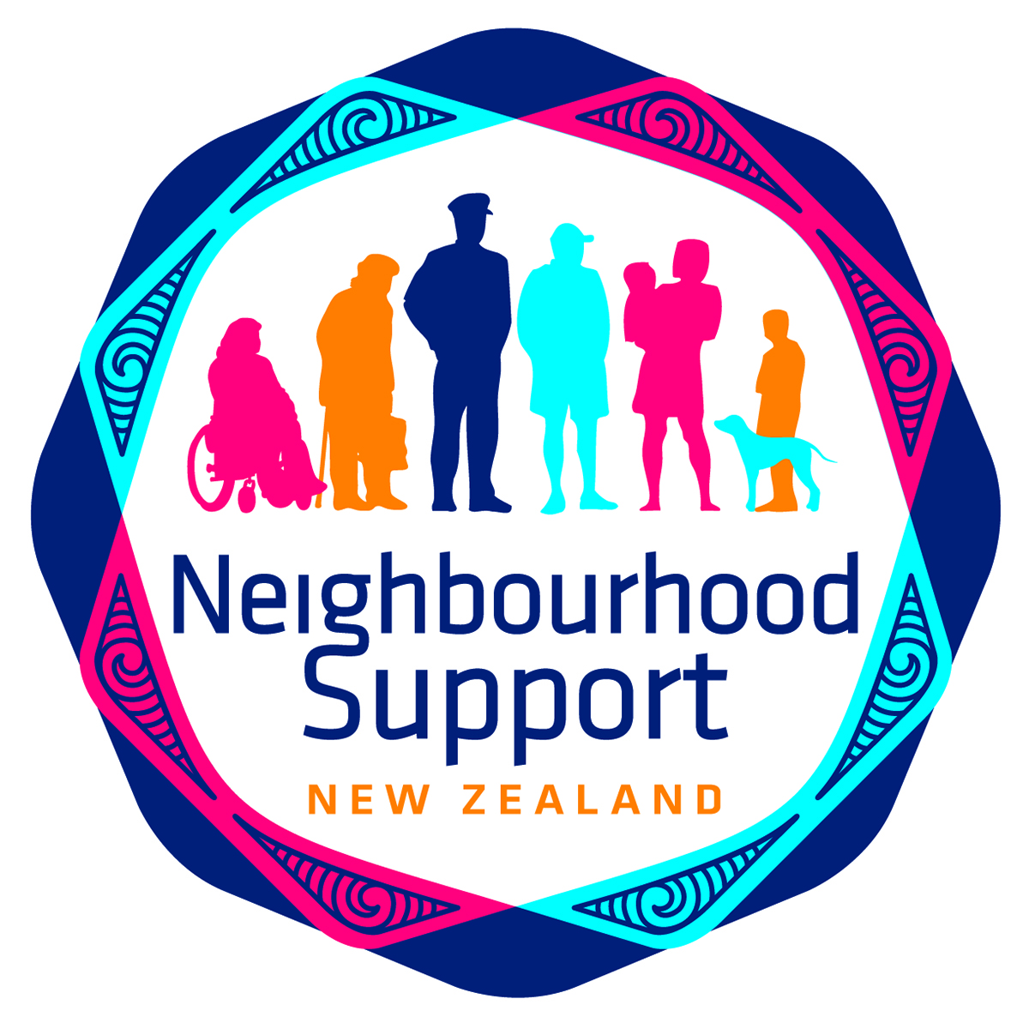



**About Neighbourhood Support New Zealand**

Neighbourhood Support NZ is a network of organisations that assists neighbourhoods and communities to:

* Be safer and to reduce crime
* Be prepared for emergencies
* Increase community connectedness and enhance well-being

There are about 70 affiliated Neighbourhood Support networks operating throughout Aotearoa New Zealand. Between them they provide information, resources and support to almost 20,000 neighbourhood groups, who in turn connect with 220,000 households nationwide.

We work closely with NZ Police and Civil Defence, as well as many other community organisations.

**How does Neighbourhood Support work?**

**Neighbourhood Support NZ**

NS Affiliated Members

NS Affiliated Members

Street Contacts

Street Contacts

Street Contacts



Households, businesses and schools

Only affiliated members of Neighbourhood Support NZ are able to use the trademarked Neighbourhood Support logo and brand. Our members are usually networked organisations that employ Area Co-ordinators, whose role it is to promote Neighbourhood Support and help to set up and support neighbourhood and street groups in their communities. A dedicated co-ordinator is an essential component of maintaining a pro-active and sustainable community network.

We promote a community-led approach so that local communities are able to develop a Neighbourhood Support model that works best for their circumstances and location.

Neighbourhood Support groups maintain up-to-date databases and are able to provide helpful information to communities. An increasing number of our members use the *Gets Ready* software and database, which was developed in response to the Christchurch earthquakes and is based on the Neighbourhood Support network model. *Gets Ready* enables localised, up-to-date and relevant information to be sent to households, including in the event of an emergency. It can, for example, pinpoint households that may be vulnerable in an emergency situation (e.g. a person who requires an electric ventilator) and match them with other households nearby who have the skills and resources to assist (e.g. they have an emergency generator.)

**How can Neighbourhood Support help local government?**

***Connected communities are happier and healthier***

International research has shown that neighbourhoods where people know and support one another are safer and healthier. Research commissioned by the Eden Project initiative The Big Lunch in the United Kingdom found that disconnected communities could be costing the UK economy £32 billion every year. This included the cost of crime and policing, as well as poor social and health outcomes, and loss of productivity. Neighbourliness can provide substantial economic benefits by increasing social connection. In communities where neighbours are connected and supportive of one another there is a reduction on public services and benefits for the environment.

***Connected communities can work together to find solutions to local issues***

Neighbourhood Support groups can assist communities to address local issues, whether it is organising a neighbourhood clean-up day, adopting a beach or stream, providing meals for families in need or adopting crime prevention measures. Connected communities are able to talk together, share ideas and information and have the confidence to find solutions.

***Connected communities are prepared for emergencies***

Neighbours are most often the first responders in any emergency. Neighbourhood Support can provide information about what to do in emergencies and connect people to a wider network of support. Neighbourhood Support NZ members maintain comprehensive community databases and are able to contact households and street groups in the event of a civil defence emergency.

**How is local government involved with Neighbourhood Support in NZ?**

City and District Councils are an important partner for Neighbourhood Support.

73% of Neighbourhood Support New Zealand members are registered charities. According to data held on the Charities Services website:

* 66% of Neighbourhood Support members who are registered charities receive funding from their local Council.
* Local councils provided almost $800,000 to Neighbourhood Support groups in the 2016 – 17 year, making them the single largest funder.
* The funding ranges from small grants of $500 through to contract funding of $369,988. The average grant is $27,341.
* 7 local Councils run Neighbourhood Support in their districts or cities, and are the affiliated member of NSNZ.
* 39% of the local Councils in NZ financially support Neighbourhood Support groups.

These statistics are a conservative estimate of local government’s contribution to Neighbourhood Support. Not all groups specify where their grant income comes from in their Charities Services’ returns, and these statistics do not take into account the remaining 27% of NSNZ members who are not registered charities.

Council support enables Neighbourhood Support members to provide sustainable services in local communities. It is used for a variety of purposes, such as:

* Operational costs, e.g. Area Coordinators salaries, vehicles and office space
* Running events
* Setting up and supporting the Gets Ready software.

**Contact us**

If you are interested in learning more about Neighbourhood Support and how we can support your local community, please contact us.

Chief Executive: Tess Casey

Postal Address: PO Box 3017, Wellington 6140

Physical Address: Level 2, Police National HQ, 180 Molesworth St, Wellington

Telephone: 04 470 4767

Website: [www.neighbourhoodsupport.co.nz](http://www.neighbourhoodsupport.co.nz)