NSNZ Accident and Incident Register
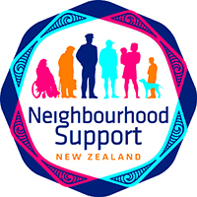

Date | Description of Incident  (Who, where and what happened?) | What follow-up action is required? | Rehab Plan  (Yes/No) | Hazard Register Updated?  (Yes/No) | WorkSafe Notification Required?  (Yes/No) | Date  Actions Completed

